**DAILY ONLINE ACTIVITIES SUMMARY**

|  |  |  |  |  |  |  |  |  |
| --- | --- | --- | --- | --- | --- | --- | --- | --- |
| **Date:** | **12-06-2020** | | | | | **Name:** | **Javahar S Goutham** | |
| **Sem & Sec** | **7Th B sec** | | | | | **USN:** | **4AL16CS132** | |
| **Online Test Summary** | | | | | | | | |
| **Subject** | | **-** | | | | | | |
| **Max. Marks** | | **-** | | **Score** | | | **-** | |
| **Certification Course Summary** | | | | | | | | |
| **Course** | **Introduction to ethical hacking(completed)**  **RPA(Completed)** | | | | | | | |
| **Certificate Provider** | | | **Eduonix** | | **Duration** | | | 9h**rs** |
| **Coding Challenges** | | | | | | | | |
| **Problem Statement**: 1. Write a Python program to implement Magic Square.  **2.** Write a Python program to print the pattern. 3. Write a Java program to find maximum width of a binary tree. | | | | | | | | |
| **Status: YES, Completed all Programs.** | | | | | | | | |
| **Uploaded the report in Github** | | | | | **YES** | | | |
| **If yes Repository name** | | | | | https://github.com/alvas-education-foundation/JavaharGoutham | | | |

Certification Course Details: (Attach the snapshot and briefly write the report for the same)

Coding Challenges Details: (Attach the snapshot and briefly write the report for the same)

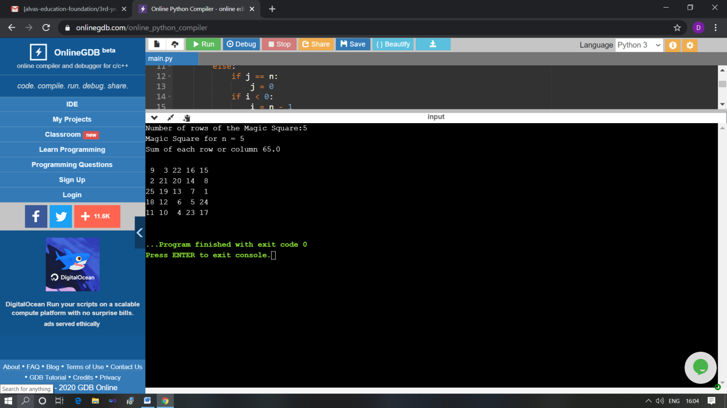

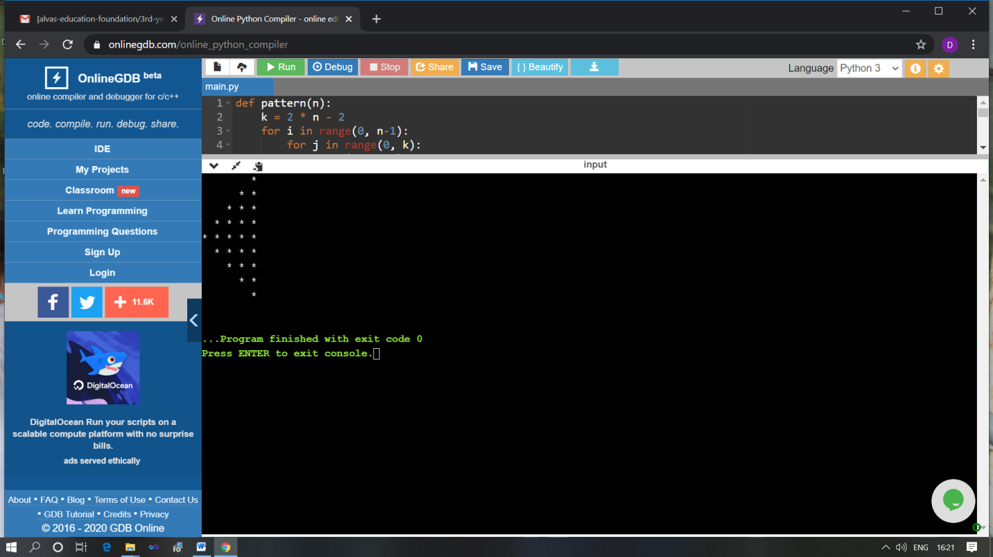

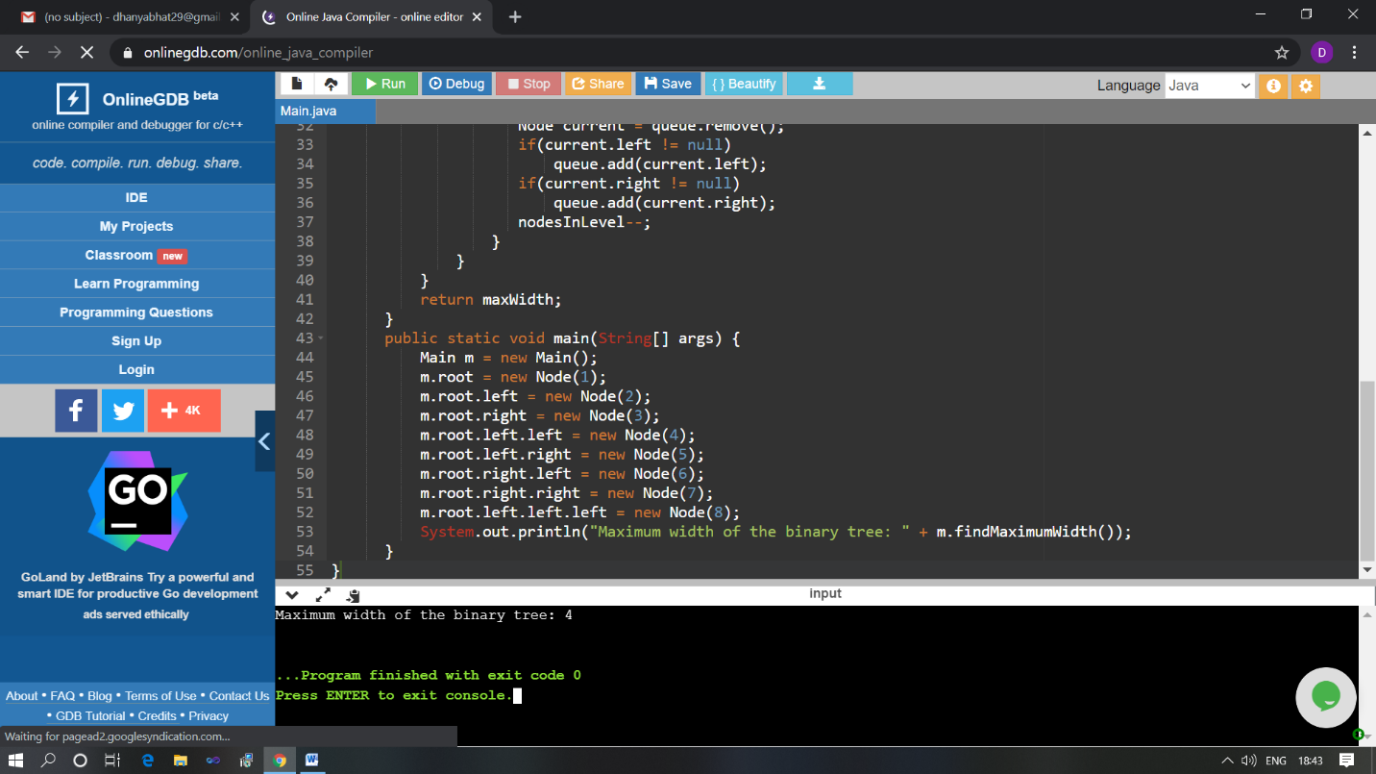

The above Programs were written and executed and the output of the same is displayed above. The code for those 3 programs have been uploaded to the github repository and the link to the same is provided on the form.